**SOCIAL K Corrective Assignment**

This Corrective Assignment serves to correct the chain of title in the SOCIAL K service mark, Registration No. 3,114,326.

On December 10, 2014 ExpertPlan, Inc. and Robert M. Thomas entered into a Trademark Purchase Agreement effective December 10, 2014 for the sale of the SOCIAL K service mark from ExpertPlan to Mr. Thomas. This Trademark Purchase Agreement was contingent in part upon the release of two security interests (First and Second Liens) granted by ExpertPlan in the SOCIAL K service mark.

On January 28, 2015 ExpertPlan recorded the release of the two security interests (First Lien at Reel/Frame 5448/0467 and Second Lien at Reel/Frame 5448/0480). On February 10, 2015, counsel for Social(K), Inc. recorded the Trademark Purchase Agreement between ExpertPlan, Inc. and Robert M. Thomas at Reel/Frame 5457/0766, believing this document to properly assign the SOCIAL K service mark from ExpertPlan, Inc. to Mr. Thomas. Counsel for Social(K), Inc. subsequently recorded a Trademark Assignment between Robert M. Thomas and Social(K), Inc. at Reel/Frame 5459/0451. On March 3, 2015, counsel for ExpertPlan, Inc. then recorded an additional document titled Trademark Assignment between ExpertPlan, Inc. and Robert M. Thomas, effective March 2, 2015 at Reel/Frame 5470/0594.

In order to accurately reflect the intent of the parties and in order to keep the SOCIAL K chain of title sequential, **the Trademark Purchase Agreement recorded at Reel/Frame 5457/0766 and the Trademark Assignment recorded at Reel/Frame 5459/0451 shall be disregarded.**

Dated this 30th day of March, 2016

**By:** 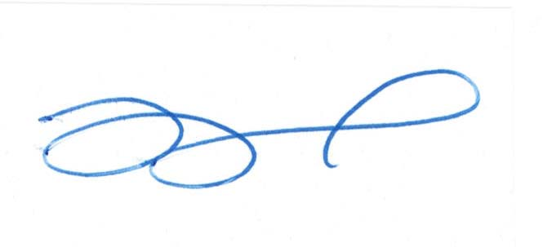  
 ______________________________   
 Lara Pearson, Esq.  
 NV Bar # 7132 CO Bar # 48103  
 Counsel for Social(k)