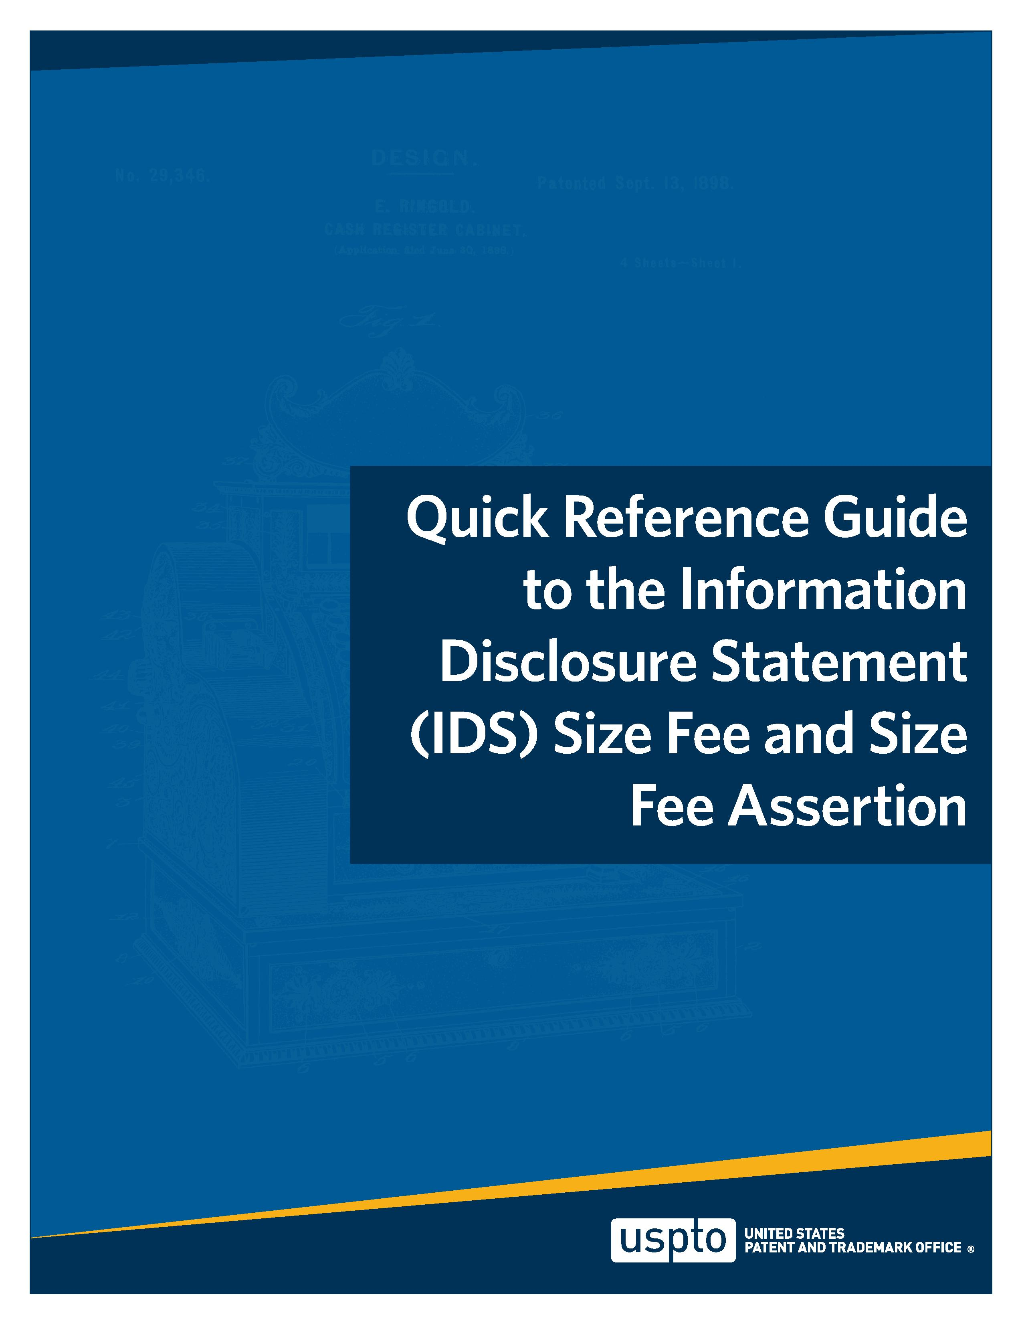
Quick Reference Guide to the Information Disclosure Statement (IDS) Size Fee and Size Fee Assertion

- What is the IDS size fee?
Answer: The IDS size fee is a new fee, which will be due with some IDS filings. The IDS size fee is required for IDS filings under 37 CFR 1.97 that cause the cumulative number of applicant-provided or patent owner-provided items to exceed certain thresholds (50,100, and 200). The requirement for this fee is set forth in § 1.97(a) for applications and § 1.555(a) for reexamination proceedings, and the fee amounts are set forth in § 1.17(v). For more information, see the FY 2025 Patents Fee Setting Rule (hereinafter "Fee Rule") preamble on pages 91923-26, and the responses to comments on pages 91950-52.
- What is the effective date of these new IDS requirements?
Answer: The new IDS size fee rule in 37 CFR 1.17(v) and the amendments to §§1.97(a),1.98(a)(4), and 1.555(a) to require the IDS size fee and size fee assertion are effective on January 19, 2025. Any IDS filed under § 1.97 on or after January 19, 2025, is subject to the new rules (i.e., size fee and size fee assertion requirements).
- What is the IDS size fee assertion?
Answer: Every IDS filed under 37 CFR 1.97 on or after the effective date of the Fee Rule will require a written statement called an "IDS size fee assertion." The statement must be clear and indicate (1) that the IDS is accompanied by the appropriate IDS size fee or (2) that no IDS size fee is required. This requirement is set forth in § 1.98(a)(4). Applicants and patentees are encouraged to use the USPTO-provided forms (SB/08 - Patent Center and SB/08c) to make their IDS size assertions.
- Are applications filed before the effective date subject to the new IDS rules? Answer: Yes, but only for an IDS filed on or after the effective date of the Fee Rule.
5. Does this new IDS size fee replace the IDS fee set forth in 37 CFR 1.17(p)?
Answer: No. The IDS fee set forth in 37 CFR 1.17(p) is an existing requirement of an IDS submitted after certain examination events such as the mailing date of a notice of allowance. The IDS size fee is a separate fee that is now required when an IDS causes the cumulative number of applicant-provided or patent owner-provided items to exceed certain thresholds.
For IDS submissions on or after the effective date of the Fee Rule no IDS fee, one IDS fee, or both IDS fees may be required, depending on the number of items in the IDS submission, and the prosecution stage during which it is submitted. For example, an IDS submitted after the effective date of the Fee Rule and after certain examination events such as the mailing date of a notice of allowance may incur both an IDS size fee under § 1.17(v) and an IDS fee under § 1.17(p). See MPEP 609.04(b) for more information about the prosecution stages that are relevant to the IDS fee under § 1.17(p).
To avoid confusion between the two IDS fees, IDS-related forms and form paragraphs have been
modified to refer to the existing IDS fee in § 1.17(p) as the "IDS timing fee" and the new IDS size fee in § 1.17(v) as the "IDS size fee."

- Does this new IDS size fee assertion replace the IDS statement specified by 37 CFR 1.97(e)?
Answer: No. The IDS statement specified in 37 CFR 1.97(e) is an existing requirement of an IDS submitted after certain examination events such as the mailing date of a notice of allowance. The IDS size fee assertion is a separate statement required for all IDS filings under § 1.97 on or after the effective date of the Fee Rule.
For IDS submissions on or after the effective date of the Fee Rule, the IDS may require only the IDS size fee assertion, or both the IDS size fee assertion and the IDS statement specified in § 1.97(e), depending on the prosecution stage during which the IDS is submitted. For example, an IDS submitted after the effective date of the Fee Rule and after certain examination events such as the mailing date of a notice of allowance would require both an IDS size fee assertion under § 1.98(a)(4) and an IDS statement specified by § 1.97(e). See MPEP 609.04(b) for more information about the prosecution stages that are relevant to the IDS statement specified by § 1.97(e).
To avoid confusion between the two, IDS-related forms and form paragraphs have been modified to refer to the existing IDS statement specified in § 1.97(e) as the "IDS timing statement" and the new IDS size fee assertion as the "IDS size fee assertion."
- What constitutes a compliant IDS size fee assertion?
Answer: There is no specific language required for the assertion, but it must be clear and indicate (1) that the IDS is accompanied by the appropriate IDS size fee or (2) that no IDS size fee is required. The appropriate IDS size fee must be identified. Non-limiting examples of compliant IDS size fee assertions include the following statements:
- No IDS size fee is required under 37 CFR 1.17(v) at this time.
- The IDS is accompanied by the IDS size fee under 37 CFR 1.17(v)(1).
- The IDS is accompanied by the IDS size fee under 37 CFR 1.17(v)(2).
- The IDS is accompanied by the IDS size fee under 37 CFR 1.17(v)(3).
An authorization to charge fees to a deposit account is not a compliant IDS size fee assertion, unless the authorization clearly identifies the particular IDS size fee that should be charged for submission of a particular IDS. A non-limiting example of a compliant IDS size fee assertion combined with an authorization to charge fees is the following: "the Director is authorized to charge the §1.17(v)(2) fee for the IDS submitted on July 1, 2026 to deposit account XX-XXXXX." General authorizations to charge fees to a deposit account are not compliant written assertions under the new §1.98(a) requirement. See 37 CFR 1.25 and MPEP 509.01 for more information about deposit account authorization practice.
Users are encouraged to use the USPTO forms (SB/08 - Patent Center and SB/08c) which contain acceptable assertion language.

- What form can I use to submit the IDS size fee and/or the IDS size fee assertion?
Answer: Applicants and patent owners are strongly encouraged to use the Information Disclosure Statement-Patent Center-auto-load version (SB/08-Patent Center) for IDS submissions. The SB/08-Patent Center is a comprehensive form that permits users to cite patent and non-patent documents, make IDS timing statements and pay IDS timing fees, and make IDS size fee assertions and pay IDS size fees.
Another option is the new Information Disclosure Statement Size Fee - Written Assertion Under 37 CFR 1.98 (SB/08c) form, which permits users to select the appropriate IDS size fee assertion and pay IDS size fees. The SB/08c form is designed for use with the PTO/SB/08a (for citing patent documents) and/or PTO/SB/08b (for citing non-patent documents), or equivalent. The new form also has instructions to assist users in selecting the appropriate IDS size fee and size fee assertion.
These forms are available on the USPTO website at www.uspto.gov/patents/apply/forms. Applicants and patent owners are not required, but are strongly encouraged to use USPTO forms.
- How do I determine which IDS size fee is due?
Answer: An IDS size fee is required for IDS filings under 37 CFR 1.97 that cause the cumulative number of applicant-provided or patent owner-provided items in the application or patent to exceed certain thresholds (50,100, and 200). The applicable fee tier is based on the cumulative count of items provided by applicant or patent owner (including items provided in the current IDS filing):
- The first tier IDS size fee in § 1.17(v)(1) applies if the IDS causes the cumulative count of items provided by applicant or patent owner to be more than 50 items, but not more than 100 items.
- The second tier IDS size fee in § 1.17(v)(2) applies if the IDS causes the cumulative count of items provided by applicant or patent owner to be more than 100 items, but not more than 200 items.
- The third tier IDS size fee in § 1.17(v)(3) applies if the IDS causes the cumulative count of items provided by applicant or patent owner to be more than 200 items.
The IDS filing must cause the cumulative count to exceed one or more of the specified thresholds in order to incur an IDS size fee. If the cumulative count already exceeds one of the thresholds before a particular IDS is filed, then that particular IDS will not incur an IDS size fee unless it causes the cumulative count to exceed a higher threshold.
10. Who is responsible for counting items, determining the appropriate IDS size fee (if any) that is due, and determining the appropriate IDS size fee assertion to make?
Answer: It is the responsibility of the applicant or patent owner to count and track the number of items they provide to the Office, and to determine the appropriate IDS size fee and IDS size fee assertion. Office personnel are not required or expected to track the number of items.

- What items are included in the cumulative count?
Answer: Each item provided by an applicant or patent owner, including each instance of a particular item, will count toward the cumulative number of items of information. "Provided" in this context refers to items cited on an IDS under 37 CFR 1.98(a)(1) by an applicant or patent owner, as explained in the Fee Rule at 91924. It does not matter whether copies of the item are submitted with the IDS. For instance, if a U.S. patent is cited on an IDS, it will be counted even though applicant does not have to provide a copy of the patent to the Office.
The count does not include items placed in the file by others (non-applicant/patent owner). For instance, the count excludes items provided by a third party, such as items cited in a third party submission under § 1.290, or items provided by a third party requester in a reexamination. The count also excludes items cited in parent applications, unless the applicant resubmits the item in the child application, as explained in the Fee Rule at 91924. The count also excludes items placed in the file by the Office as part of an Office program such as the Relevant Prior Art initiative.
- Are duplicate items counted twice in the cumulative count?
Answer: Yes. Each instance of a particular item will count toward the cumulative number of items of information. For example, if the applicant lists a particular item (e.g., a journal article authored by Marie Curie) twice on the same IDS, each listing will count. Similarly, if the applicant lists the same item in multiple IDSs in the same application, each of those listings will count. However, if a particular item provided by an applicant or patent owner on an IDS was not considered because the item was noncompliant and that particular item is provided on an IDS a second time in the same application or patent, it will not be counted again. See Fee Rule at 91924 and Example 3 in the next section of this document.
- How is the cumulative count determined?
Answer: The count is determined for each application or patent separately. For an application, the count begins at filing and continues to increment until issuance. New applications such as continuing applications, reissue applications, and Continued Prosecution Applications (CPAs) start with a count of zero. Filing an RCE will not reset the count because an RCE is not the filing of a new application. For a post-issuance proceeding such as a supplemental examination or reexamination, the count will start at zero.
- How do I count items in an application filed before the effective date of the new IDS rules?
Answer: For an application, the cumulative count begins at filing and continues to increment until issuance. Thus, items provided by applicant or patent owner before the effective date should be considered part of the cumulative count when determining if an IDS size fee is due for an IDS that is filed on or after the effective date of the new IDS rules. If the cumulative count already exceeds one of the thresholds before the effective date, then a subsequent IDS filing made on or after the effective date will not incur an IDS size fee unless it causes the cumulative count to exceed a higher threshold. See Examples 6-9 for situations that may arise for applications or post-issuance proceedings that were pending prior to the effective date of the new IDS rules.

The count works in the same manner for post-issuance proceedings, beginning at the time of submitting the request for supplemental examination or reexamination.
- Applicant or patent owner already provided more than 200 items in an application or post-issuance proceeding before the effective date of the new IDS rules. If applicant or patent owner files an IDS on or after the effective date providing additional items, is an IDS size fee due?
Answer: No. If the cumulative count already exceeds the highest threshold of 200 items before the effective date, then any subsequent IDS filing made on or after the effective date will not incur an IDS size fee. The subsequent IDS must still include an IDS size fee assertion indicating that no fee is due. See Example 9.
- What happens if an IDS is filed without an IDS size fee assertion?
Answer: If the IDS size fee assertion is missing in an IDS filed on or after the effective date of the new IDS rules, the IDS is non-compliant with 37 CFR 1.98(a)(4). The IDS will be placed in the file but not considered.
- What happens if an IDS is filed without payment of the IDS size fee indicated in the IDS size fee assertion?
Answer: If the IDS size fee indicated in the IDS size fee assertion is missing or insufficient, then Office personnel will look for a deposit account authorization. If the Office has been properly authorized to charge a deposit account that contains sufficient funds, the Office will charge the identified IDS size fee, and continue review of the IDS in accordance with existing practice in MPEP 609. If the Office is not able to charge the missing or insufficient fee to a deposit account that contains sufficient funds, the IDS is non-compliant with 37 CFR 1.97(a). The IDS will be placed in the file but not considered.
- If multiple IDS filings are made in the same application, do I have to pay multiple IDS size fees?
Answer: It depends. An IDS size fee is required for IDS filings under 37 CFR 1.97 (and IDS filings under § 1.555(a) by individuals associated with patent owner in a reexamination proceeding) that cause the cumulative number of applicant-provided or patent owner-provided items in the application or patent to exceed certain thresholds (50,100, and 200). As shown in Example 4, if a second or subsequent IDS does not cause the cumulative count to exceed the number of items already covered by a previously paid IDS size fee, then no additional IDS size fee would be due. In contrast, as shown in Example 5, if a second or subsequent IDS causes the cumulative count to exceed a higher threshold, then an additional IDS size fee would be due.
- What is the maximum IDS size fee due in a single application or post-issuance proceeding?
Answer: The maximum IDS size fee due in a single application or post-issuance proceeding is the amount of the third tier fee under 37 CFR 1.17(v)(3). Note that the amount due for the second and third tier fees under §§1.17(v)(2) and (v)(3) is the difference between the currently applicable fee and the fee(s) previously paid.

For example, in February 2025, applicant filed a first IDS citing 60 items and paid the first tier IDS size fee under §1.17(v)(1). In April 2025, applicant filed a second IDS citing 50 items, bringing the cumulative count to 110 items. The second IDS will require payment of the second tier IDS size fee under §1.17(v) (2). The amount due with the second IDS will reflect the prior payment under §1.17(v)(1). In this situation, applicant would owe the difference between the current fee amount stated in §1.17(v)(2) and the amount of the previous payment under §1.17(v)(1).
20. What happens if I forget to make an IDS size fee assertion, and/or forget to pay the IDS size fee (if due)
when I am filing a submission in the Quick Path Information Disclosure Statement (QPIDS) program?
Answer: An IDS filing that lacks the IDS size fee assertion and any applicable IDS size fee is noncompliant with 37 CFR 1.97 and 1.98. In other words, it has a §§1.97/1.98 deficiency. If such a noncompliant IDS is filed in the Quick Path Information Disclosure Statement (QPIDS) program, the submission does not comply with the requirements of the QPIDS program due to the §§1.97/1.98 deficiency. In this situation, the non-compliant IDS should not be considered, and applicants should expect the Office to enter the conditional RCE because applicant's submission does not comply with the requirements of the QPIDS program. Entry of the conditional RCE will provide a time period under § 1.97(b)(4) for applicant to submit a compliant IDS. Unless applicant promptly submits a compliant IDS fixing the deficiencies, the subsequent Office action will most likely be a re-allowance (because the noncompliant IDS should not be considered).
The QPIDS transmittal form (SB/09) has been revised to specify that the IDS size fee assertion and any applicable IDS size fee are required to comply with the QPIDS program.
Examples
The following examples are not exhaustive but illustrate the most common situations anticipated to raise questions about whether payment of the new fees under §1.17(v) is required. Fee amounts shown below are the fees in effect on January 19, 2025. Discounts are unavailable for fees under § 1.17(v). Examples 1-5 below are copied from the Fee Rule at page 91925. Examples 6-9 are new and address situations that may arise for applications or post-issuance proceedings that were pending prior to the effective date of the new IDS rules.
Example 1: Single IDS submission with cumulative count less than fee threshold.
If an applicant submits a single IDS during prosecution with 30 items of information, no IDS size fee would be due. At the time of submitting the IDS, the applicant certifies that no IDS size fee is required.
Example 2: Single IDS submission with cumulative count exceeding fee threshold.
If an applicant submits a single IDS during prosecution with 101 items of information, the $500 fee under
§ 1.17(v)(2) for exceeding 100 items of information, but not exceeding 200, is due. At the time of submitting
the IDS, the applicant must certify that the § 1.17(v)(2) fee is due and pay the fee.

Example 3: Re-submission of item previously refused consideration.
If an applicant submits a first IDS with 49 items of information, no IDS size fee would be due. At the time of submitting the first IDS, the applicant certifies that no IDS size fee is required. When the examiner evaluates the first IDS, the examiner discovers that the copy of a particular item (a journal article authored by Marie Curie) provided by the applicant is blurry and illegible. Accordingly, the examiner does not consider the Curie article. Subsequently, in that same application, the applicant files a second IDS with two items of information, including the same Curie article previously listed and a newly cited item. Because the Curie article was previously before the examiner and refused consideration for being noncompliant, its resubmission in the second IDS is not counted again. Thus, the cumulative number of items of information in the application after submission of the second IDS is only 50 (the total of the 49 items from the first IDS, and the newly cited item from the second IDS), and no IDS size fee would be due. At the time of submitting the second IDS, the applicant certifies that no IDS size fee is required.
Example 4: Multiple IDS submissions covered by the same fee.
If an applicant files a first IDS with 61 items of information, the $200 fee under § 1.17(v)(1) for exceeding 50 items of information, but not exceeding 100, is due. At the time of submitting the first IDS, the applicant certifies that the § 1.17(v)(1) fee is due and pays the fee. Subsequently, in that same application, if the applicant files a second IDS with 10 items of information, the cumulative number of items of information in the application would be 71. No additional fee would be due, because the cumulative number of items is still in the range covered by the § 1.17(v)(1) fee that was previously paid. While the applicant must still include a certification with the second IDS, the applicant may certify that no IDS size fee is required with submission of the second IDS.
Example 5: Multiple IDS submissions requiring additional fees.
If an applicant files a first IDS with 51 items of information, they would certify that the § 1.17(v)(1) fee for exceeding 50 items of information, but not exceeding 100, is due and pay the fee of $200. Subsequently, in that same application, if the applicant files a second IDS with 50 items of information, the cumulative number of items of information in the application would be 101. The applicant would then certify that the § 1.17(v)(2) fee for exceeding 100 items of information, but not exceeding 200, is due, and pay $300 (the $500 fee under § 1.17(v)(2) minus the $200 previously paid). Further, in that same application, if the applicant files a third IDS with 100 items of information, the cumulative number of items of information in the application would be 201. The applicant would then certify that the § 1.17(v)(3) fee for exceeding 200 items of information is due and pay $300 (the $800 fee under § 1.17(v)(3) minus the $500 previously paid). Thus, in this example, the applicant would pay a combined IDS size fee of $800 for the three IDSs filed during the pendency of the application.
Example 6: Filing subsequent IDS in an application that predates the effective date of the final rule; no IDS size fee due even though cumulative count exceeds first fee threshold.
Prior to the effective date of the Fee Rule, applicant submitted a first IDS citing 55 items. No IDS size fee was due for the first IDS because it was filed before the effective date. After the effective date, applicant files a second IDS citing 10 items. The cumulative count of items provided by the applicant is now 65 items. However, no IDS size fee is due for the second IDS, because it did not cause the cumulative count to exceed

any of the thresholds specified in the rule (50,100, and 200). Applicant must still include an IDS size fee assertion in the second IDS indicating that no IDS size fee is due.
Example 7: Filing subsequent IDS in an application that predates the effective date of the final rule; first tier IDS size fee due.
Prior to the effective date of the Fee Rule, applicant submitted a first IDS citing 35 items. No IDS size fee was due for the first IDS because it was filed before the effective date. After the effective date, applicant files a second IDS citing 30 items. The cumulative count of items provided by the applicant is now 65 items. The $200 fee under § 1.17(v)(1) is due for the second IDS, because the second IDS caused the cumulative count to exceed the first threshold (50 items) specified in the rule. At the time of submitting the second IDS, the applicant must certify that the § 1.17(v)(1) fee is due and pay the fee.
Example 8: Filing subsequent IDS in an application that predates the effective date of the final rule; second tier IDS size fee due.
Prior to the effective date of the Fee Rule, applicant submitted a first IDS citing 70 items. No IDS size fee was due for the first IDS because it was filed before the effective date. After the effective date, applicant files a second IDS citing 40 items. The cumulative count of items provided by the applicant is now 110 items. The $500 fee under § 1.17(v)(2) is due for the second IDS, because the second IDS caused the cumulative count to exceed the second threshold (100 items) specified in the rule. At the time of submitting the second IDS, the applicant must certify that the § 1.17(v)(2) fee is due and pay the fee. Because no IDS size fees were previously paid in this application, the full amount of $500 is due.
Example 9: Filing subsequent IDS in an application that predates the effective date of the final rule; no IDS size fee due even though cumulative count exceeds third fee threshold.
Prior to the effective date of the Fee Rule, applicant submitted a first IDS citing 205 items. No IDS size fee was due for the first IDS because it was filed before the effective date. After the effective date, applicant files a second IDS citing 10 items. The cumulative count of items provided by the applicant is now 215 items. However, no IDS size fee is due for the second IDS, because it did not cause the cumulative count to exceed any of the thresholds specified in the rule (50,100, and 200). Applicant must still include an IDS size fee assertion in the second IDS indicating that no IDS size fee is due.

